Name: Truong Dang Truc Lam  
ID: B2111933   
Class: CT209H-M04

**LAB 2**

**Creating and Managing Active Directory Users,   
Computers, Groups and Organizational Unit**

**EXERCISE 1: CREATING COMPUTER OBJECTS**

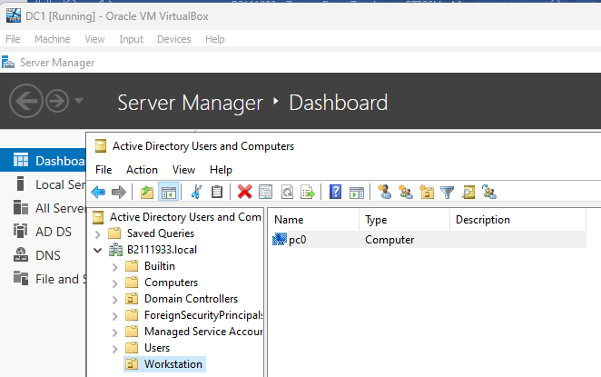

Create an Organizational Unit "Workstation" within the domain “.b2111933.local” and then create a computer "pc0" in that OU. The "Domain Computers" group is assigned permissions  
to manage the computer object.

**EXERCISE 2: CREATING ORGANIZATIONAL UNIT AND A SINGLE USER**

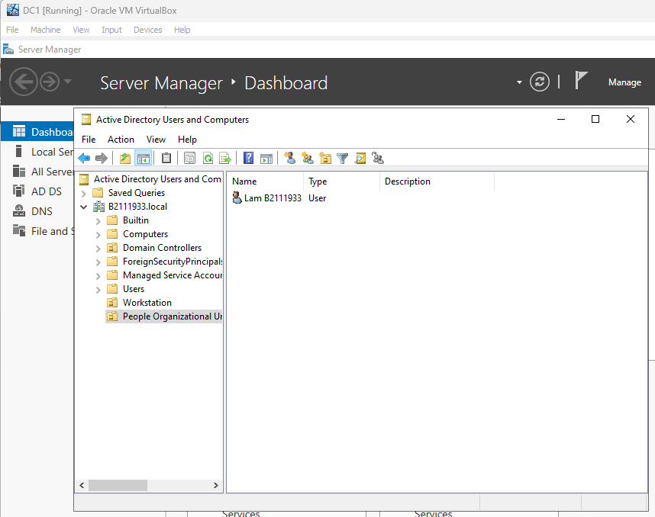

Create an Organizational Unit named "People Organizational Unit" within the current domain, then create a user account “Lam B2111933” within that OU.

**EXERCISE 3: USING ACTIVE DIRECTORY ADMINISTRATIVE CENTER**

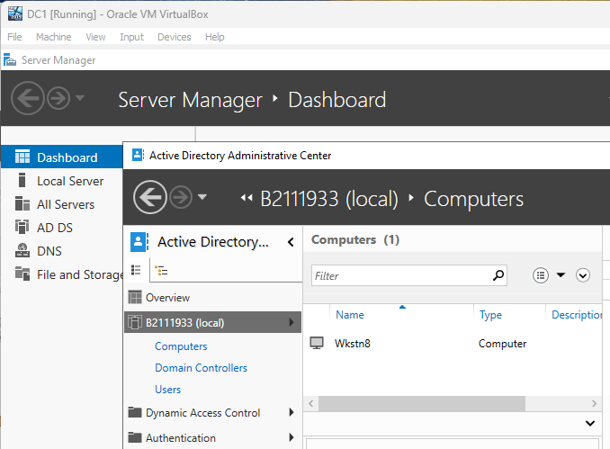

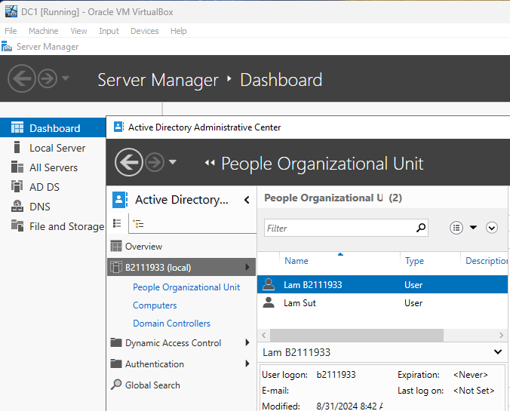

Similarly, we can create objects with Active Directory Administrative Center.

**EXERCISE 4: CREATING USERS WITH POWERSHELL**

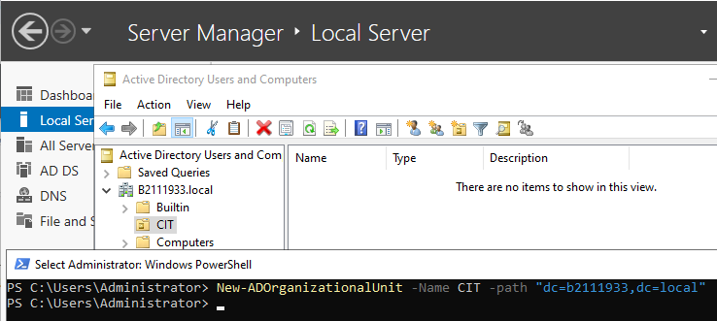

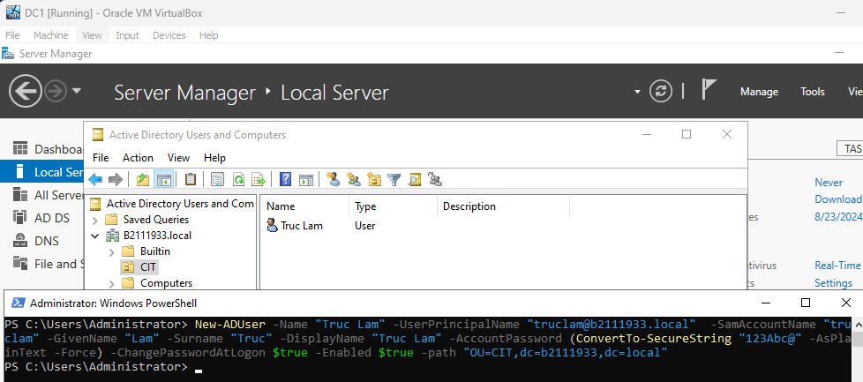

We can also create objects with Windows PowerShell

**EXERCISE 5: Joining a computer to a domain**

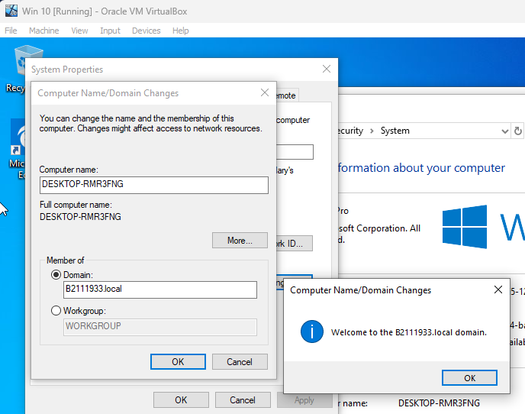

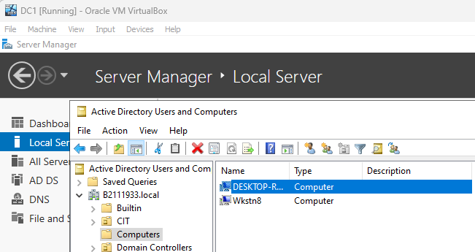

Create another Windows 10 VM, then join it to domain “.B2111933.local”

**EXERCISE 6: CREATING GROUPS**

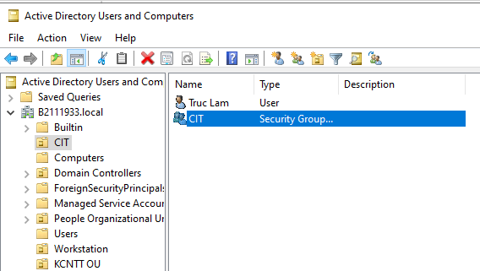

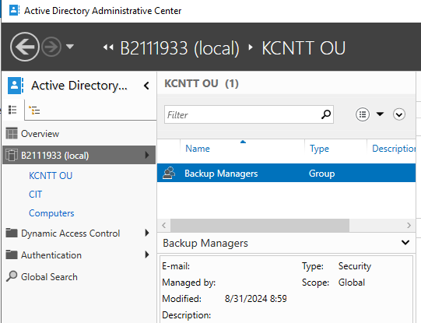

Create 2 groups with different scopes within the “.B2111933.local” domain.  
"CIT" is a Domain Local Group and "Backup Managers" is a Global Group.

**EXERCISE 7: CREATING MULTIPLE OUS AND USERS**

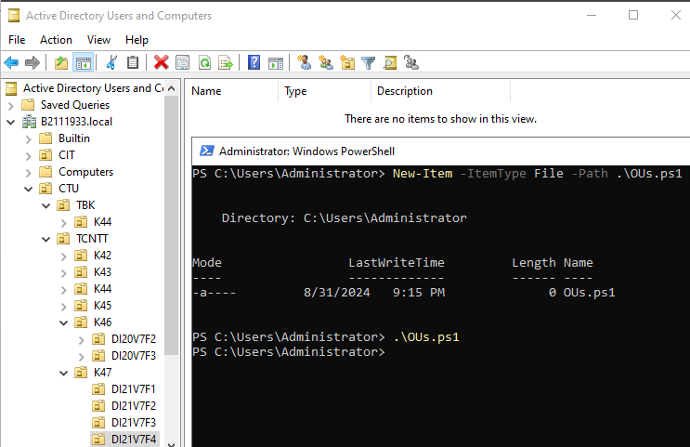

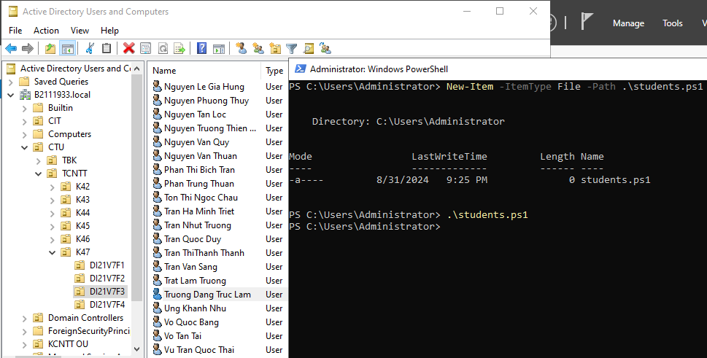

Finally, we can create multiple OUs and Users with Powershell script file (.ps1 file).  
Each line of the .ps1 file contains a command similar to Exercise 4.